CSCI 2467
Lab 2

- A shipping company uses the following table to calculate the cost (in dollars) of shipping based on the weight of the package (in pounds).
>0 and <= 1 3.50
>1 and <= 3 5.50
>3 and <= 10 8.50
>10 and <=20 10.50
Write a program, using nested if statements, that prompts the user to enter the weight of the package and display the shipping cost. If the weight is greater than 20 pounds, display a message “the package cannot be shipped.”

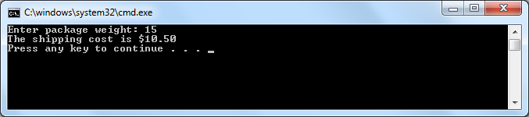

- Write a program that prompts a user to enter a US dollar amount. Output a table similar to the one in the example below. The second prompt should ask the user to enter a 1 to convert to euros, a 2 to convert to pounds and a 3 to convert to rubles. Find the current exchange rates. Use a switch statement to make the conversion and output the converted amount.

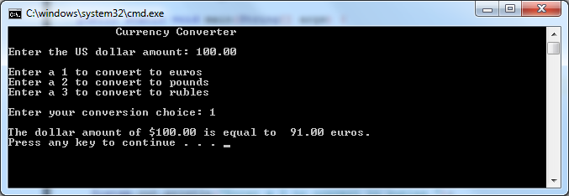

Submit both files via blackboard.

